

BSD23 Live & Authorised Ranges Workbook

Business Systems Design

Author: Sean Johnson
Date: 28/07/2006

Version: 0.4

Authority: | Ewen Macinnes (Programme Director)
Signature:
Authority: | John Wootton (Project Manager for Commercial)
Signature:
Authority:
Signature:
Authority:
Signature:

Contents
1. Introduction 3
1.1 Background 3
1.2 Document Purpose 3
1.3 Document Scope 3
1.3.1 In Scope 3
1.3.2 Out of Scope 3
2. System Design 4
2.1 Workbook Overview 4
2.2 Available Ranges 4
2.3 Workbook Build Wizard 4
2.4 Workbook Layout 6
2.5 Live and Authorised Ranges Workbook 7
2.5.1 Core Range Tab 7
2.5.1.1 All Range Classes Window 7
2.5.1.2 All Range Classes / Clusters Window 8
2.5.1.3 Store Count Window 9
2.5.2 Overlay Range Tab 10
2.5.2.1 Overlay Range Window 10
2.5.3 Summary Tab 11
2.5.3.1 Summary Window 11
2.5.3.2 Range Count Window 12

Introduction

Background
The Commercial Range Support Tool (CRST) is being developed to replace and enhance today’s ranging functionality. Instead of making range changes in CW, ranges will be created in CRST before being passed to ProSpace for planning.

Document Purpose
The document will describe the Live And Authorised Ranges Workbook where users will be able to view any range currently live in store or any range authorised but not yet live in store.

Document Scope
The major requirements to support ranging in CRST were captured and prioritised in BRD4 Ranging.

In Scope
The detailed requirements addressed in this document are:
- Viewing Live and Authorised Ranges (basics)

Out of Scope
- Viewing Performance Actuals for Live Ranges
- Viewing Level Run Down for Live Ranges

System Design

Workbook Overview
Dummy New Lines
Ranging
Sales History
Live Ranges
Workbooks
Dummy New Lines is used to set up and maintain dummy products and to link dummy products to authorised products. This is unchanged.
Ranging is used to perform range changes. This is unchanged.
Sales History is used to select the history period for the performance data used in the Ranging Workbook. This is unchanged.
Live Ranges allows a user to view any range currently live in store or any range authorised but not yet live in store. This is a new workbook.

Available Ranges
For each Merchandising Group two types of events may be viewed
- The latest ranging event that has reached its event effective date will be available. All Store Clusters planned within the event will be shown. Some Store Clusters may not have reached their effective date if the Store Cluster effective date was set to be later than the event effective date.
- Any ranging events that have been authorised but not reached their event effective date will also be available for selection

Workbook Build Wizard

Process Flow
The workbook build wizard will guide the user through the following process

Select Range
Event
Build
Workbook
Select Live
Ranges Workbook

Sample Screens
Select Range Event
- LIVE
Next >>
B1B PRE PACKED BREAD, NEW, 2005 48
B6B BREAD, UPADTE, 2005 48
Cancel
F1B FROZEN READY MEALS, UPADTE, 2006 10
- AUTHORISED (not yet Live)
B1B PRE PACKED BREAD, UPDATE, 2006 12

B6B BREAD, UPDATE, 2006 12

F6B READY MEALS, OOC, 2006 04

Interacting With The Screens

Select Range Event
The user will choose the Range Event to be viewed. For each Merchandising Group CRST will show the event type and range effective week of the latest live range plus any events authorised but not yet live. CRST will present the user with a list of Range Events grouped by Merchandising Group type (e.g. Main, Supplementary, Express, etc).
CRST will only show those Merchandising Groups to which the user has ranging access. Security access for ranging within CRST is defined at Sub Group level. The system determines which Merchandising Groups a user has access for by cross-referencing the relationships between Sub Group and Merchandising Group. A Merchandising Group will appear in the list if the user has been granted ranging access for one of more Sub Groups within the Merchandising Group.
The user must select a Merchandising Group / Range Event before proceeding. The user can select only one Merchandising Group / Range Event. Once the user has made their choice they will press ‘Finish’ to end the build wizard.
The user can exit from the build wizard without building a workbook by selecting ‘Cancel’ and will return to the workbook selection screen.
RPAS will then build the workbook for the Merchandising Group / Range Event selected by the user.
All Store Clusters linked to the Merchandising Group and Range Event will automatically be included in the workbook.

All TPNBs contained in the Merchandising Group for the Range Event with authorisation status of “A” or “U” will automatically be included in the workbook (this is the same rule used for the Ranging Workbook).

Workbook Layout

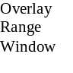
Overlay
Range Tab

Live Ranges
Summary
Window
Range Count Window
Summary
Tab
Core Range
Tab
All Range
Classes
Window
Store Count Window
Window
Classes/Clusters
The Live Ranges workbook is organised as a number of tabs.
- The Core Range Tab contains two windows:
- The All Range Classes Window, which is used to view the core range for each Store Cluster and Range Class using a TPNB centric viewpoint (i.e. shows how a TPNB is ranged across all Range Classes).
- The All Range Classes / Clusters Window, which is used to view the core range for each Range Class using a Store Cluster by TPNB centric viewpoint (i.e. shows Store Cluster for each TPNB that is ranged across all Range Classes).
- The Store Count Window, which shows information about the number of stores allocated to each Range Class within a Store Cluster. This window is linked to the ranging windows so that it always shows information for the Store Cluster currently being viewed.
- The Overlay Range Tab contains one windows:
- The Overlay Range Window, which is used to view how specific TPNBs are used to overlay the core range for each Store Cluster and Range Class.
- The Summary Tab contains two windows:
- The Summary Window, which shows the lowest and highest Range Class for each product in each Store Cluster and the number of stores the product will be ranged in
- The Range Count Window, which shows the number of products in the range for each Store Cluster

Live and Authorised Ranges Workbook

Core Range Tab

All Range Classes Window
The All Range Classes Window is used to show the core range for each Store Cluster and Range Class using a TPNB centric viewpoint (i.e. shows how a TPNB is ranged across all Range Classes).

Sample Screen
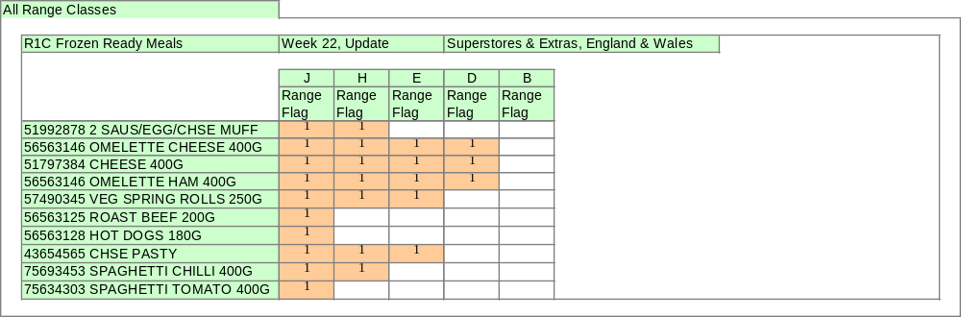

Screen Layout
The Merchandising Group, Range Change and Store Cluster currently being viewed will be displayed at the top left of the screen.
The Metrics will be displayed within the Supported Range Classes for the Store Cluster currently being viewed as columns across the screen.
TPNBs will be displayed as rows down the screen.

Metrics

Defined Metrics
Metric | Description | At | Type
Range Flag | Range flag showing if the TPNB is ranged. | TPNB  Store Cluster Range Class | Visual

Interacting With The Screen

Grouping
TPNBs can be grouped within Sub Groups, Brand and Tesco/Non Tesco.

Changing The Store Cluster Currently Being Viewed
At any point in time a user can change the Store Cluster currently being viewed to another Store Cluster within the Range Change. The range window and all other windows in the workbook will change to display the new Store Cluster.
RPAS provides a ‘Next’ and ‘Previous’ button next to the Store Cluster currently displayed to achieve this.

Supported Range Classes
CRST will only show those Range Classes supported within the Store Cluster currently being viewed. This will apply to all windows where Range Classes are shown.

All Range Classes / Clusters Window
The All Range Classes / Clusters Window is used to show the core range for each Range Class using a Store Cluster by TPNB centric viewpoint (i.e. shows how a Store Cluster within a TPNB is ranged across all Range Classes).

Sample Screen

All Range Classes
R1C Frozen Ready Meals
Week 22, Update
J
H
E
D
B
Range
Flag
Range
Flag
Range
Flag
Range
Flag
Range
Flag
51992878 2 SAUS/EGG/CHSE MUFF
1
1
Superstores & Extra, Scotland
1
1
1
1
1
1
1
1
56563146 OMELETTE HAM 400G
1
1
1
1
1
1
1
1
56563128 HOT DOGS 180G
1
1
1
1
1
1
75634303 SPAGHETTI TOMATO 400G
1
Metro, UK
Metro, UK
Superstores & Extra, Scotland
Superstores & Extra, Scotland
Metro, UK

Screen Layout
The Merchandising Group and Range Change currently being viewed will be displayed at the top left of the screen.
The Metrics will be displayed within the Supported Range Classes as columns across the screen.
Store Clusters within TPNBs will be displayed as rows down the screen.

Metrics

Defined Metrics
Metric | Description | At | Type
Range Flag | Range flag showing if the TPNB is ranged. | TPNB  Store Cluster Range Class | Visual

Interacting With The Screen

Grouping
TPNBs can be grouped within Sub Groups, Brand and Tesco/Non Tesco.

Supported Range Classes
CRST will only show those Range Classes supported within the Store Cluster currently being viewed. This will apply to all windows where Range Classes are shown.

Store Count Window
The Store Count Window shows the number of stores in each Range Class for the Store Cluster being viewed.

Sample Screen
Store Count
R1C Frozen Ready Meals
Week 22, Update
Superstores & Extras, England & Wales
J
H
E
D
B
Number Of Stores
10
15
18
12
8
Number Of Mods
14
12
10
8
6
Cumulative Number of Stores
25
43
55
63
10

Screen Layout
The Merchandising Group, Range Change and Store Cluster currently being viewed will be displayed at the top left of the screen.
The Supported Range Classes for the Store Cluster currently being viewed will be displayed as columns across the screen.
The metrics will be displayed as rows down the screen.

Metrics

Defined Metrics
Metric | Description | At | Type
Number Of Stores | The number of Stores for this Range Class within the Store Cluster | Store Cluster Range Class | Number
Cumulative Number of Stores | The total number of Stores a TPNB would be ranged to in the Store Cluster if it were ranged to this Range Class (this assumes no fragmentation of the Range Class hierarchy) | Store Cluster Range Class | Number
Number Of Mods | The number of Mods (or range of Mods) represented by the Range Class | Store Cluster Range Class | Text

Overlay Range Tab

Overlay Range Window
The Overlay Range Window is used to view products overlaid on the core range for each Store Cluster for each Overlay Type specified in Pre-Ranging.

Sample Screen
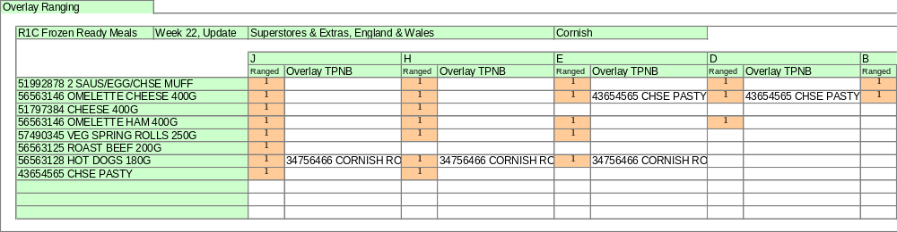

Screen Layout
The Merchandising Group, Range Change, Store Cluster and Overlay Type currently being viewed will be displayed at the top left of the screen.
The Metrics will be displayed within the Supported Range Classes for the Store Cluster being viewed as columns across the screen.
Core range TPNBs will be displayed as rows down the screen. Only TPNBs ranged within the Store Cluster currently being viewed will be displayed

Metrics

Defined Metrics
Metric | Description | At | Type
Ranged | Shows which Range Classes each core TPNB is ranged to in the Store Cluster being overlaid. | TPNB Store Cluster Range Class | Tick
Overlay TPNB | The TPNB used as an overlay for the core TPNB for the Range Class, Store Cluster and Overlay Type¹. | TPNB Store Cluster Range Class Overlay Type | Text

Notes On Metrics

¹ Overlay TPNB
Shows the product code and description of the TPNB to be used as an overlay.

Interacting With The Screen

Changing The Overlay Type
At any point in time a user can change the Overlay Type being viewed to another Overlay Type. The Overlay Ranging Window will change to display the new Overlay Type.
RPAS provides a ‘Next’ and ‘Previous’ button next to the Overlay Type currently displayed to achieve this.

Summary Tab

Summary Window
The Summary Window displays information showing how each TPNB is used across the Store Clusters.

Sample Screen
Store Count & Range Class Summary
R1C Frozen Ready Meals
51992878 2 SAUS/EGG/CHSE MUFF
56563146 OMELETTE CHEESE 400G
J - D
42
F - B
20
51797384 CHEESE 400G
J - D
42
F - B
20
56563146 OMELETTE HAM 400G
J - F
25
F - B
20
57490345 VEG SPRING ROLLS 250G
J - B
63
56563125 ROAST BEEF 200G
56563128 HOT DOGS 180G
F - B
15
43654565 CHSE PASTY
H - D
20
F - A
25
75693453 SPAGHETTI CHILLI 400G
F - D
15
G - A
18
75634303 SPAGHETTI TOMATO 400G
F - F
25
Superstores & Extras, England
& Wales
Superstores & Extras, Scotland
Range Class
Range Class
Stores Ranged
Stores Ranged

Screen Layout
The Merchandising Group and Range Change will be displayed at the top left of the screen.
The Metrics will be displayed within each Store Cluster as columns across the screen.
TPNBs will be displayed as rows down the screen.

Metrics

Defined Metrics
Metric | Description | At | Type
Stores Ranged | The number of Stores a TPNB is ranged to. | TPNB Store Cluster | Number
Range Class | The Range Class a TPNB is ranged to within the Store Cluster. | TPNB Store Cluster | Text

Interacting With The Screen

Grouping
TPNBs can be grouped within Sub Groups , Brand and Tesco/Non Tesco.

Range Count Window
The Range Count Window gives summary information of the number of products in a range used within a Store Cluster.

Sample Screen
Range Count
R1C Frozen Ready Meals
Week 22, Update
Number Of Products Ranged
E
D
C
B
A
39
35
29
20
10
12
10
8
6
4
3
3
3
10
10
8
6
14
12
10
8
6
Superstores & Extras, England & Wales
Superstores & Extras, Scotland

Screen Layout
The Merchandising Group, Range Change and Store Cluster currently being viewed will be displayed at the top left of the screen.
The Supported Range Classes for the Store Cluster currently being viewed will be displayed within each Metric as columns across the screen.
By default the view will be for Total Products.

Metrics

Defined Metrics
Metric | Description | At | Type
Number Of Products Ranged | The number of TPNBs in the range. | Sub Group Store Cluster Range Class | Number

Grouping
TPNBs can be grouped within Sub Groups , Brand and Tesco/Non Tesco.
Document Control

Project: | Commercial Range Support Tool
Document Title: | BSD23 Live & Authorised Ranges Workbook
Document Location: | G:\Ranging\Commercial Range Support Tool\Functional Requirements\BSDs
Distribution:

Change Record
Date | Author | Change Description | Version
12/07/2006 | Sean Johnson | Initial Draft | 0.1
13/07/2005 | Sean Johnson | Update as per Ian Mcleod | 0.2
20/07/2005 | Sean Johnson | Update with changes as per John Wootton | 0.3
28/07/2005 | Sean Johnson | Update with changes as per John Wootton | 0.4

